**Cassandra**

1. Check Java and Python environment variables are set:

This PC-> Properties ->Advanced System Setting -> Environment Variables

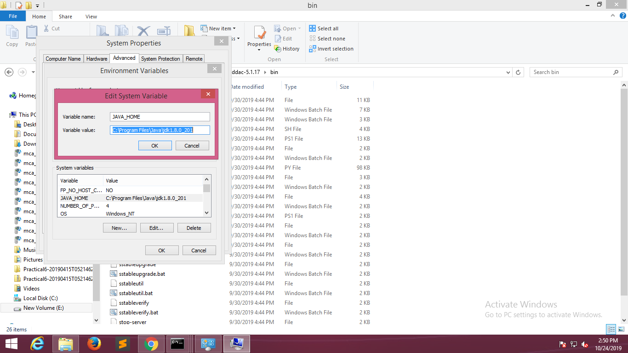

1. Download Cassandra

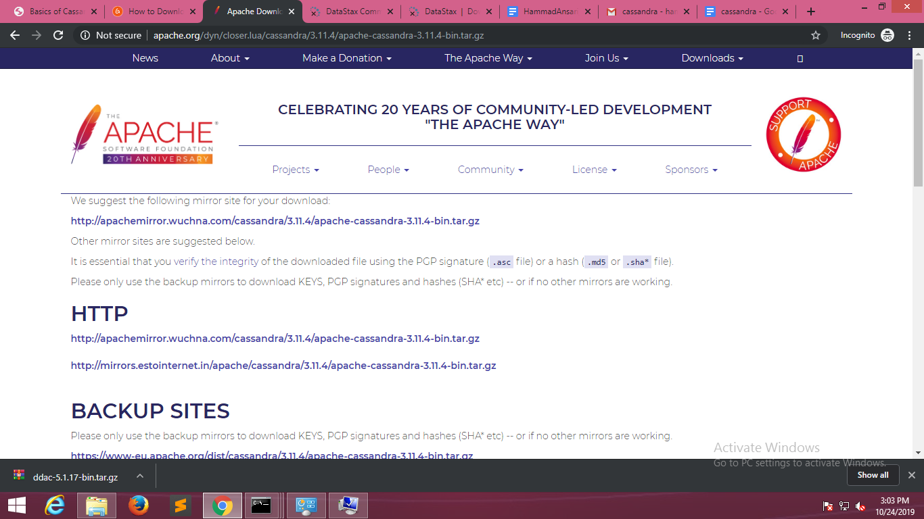

1. Setting environment variable of cassandra_home to bin of the cassandra installation files.

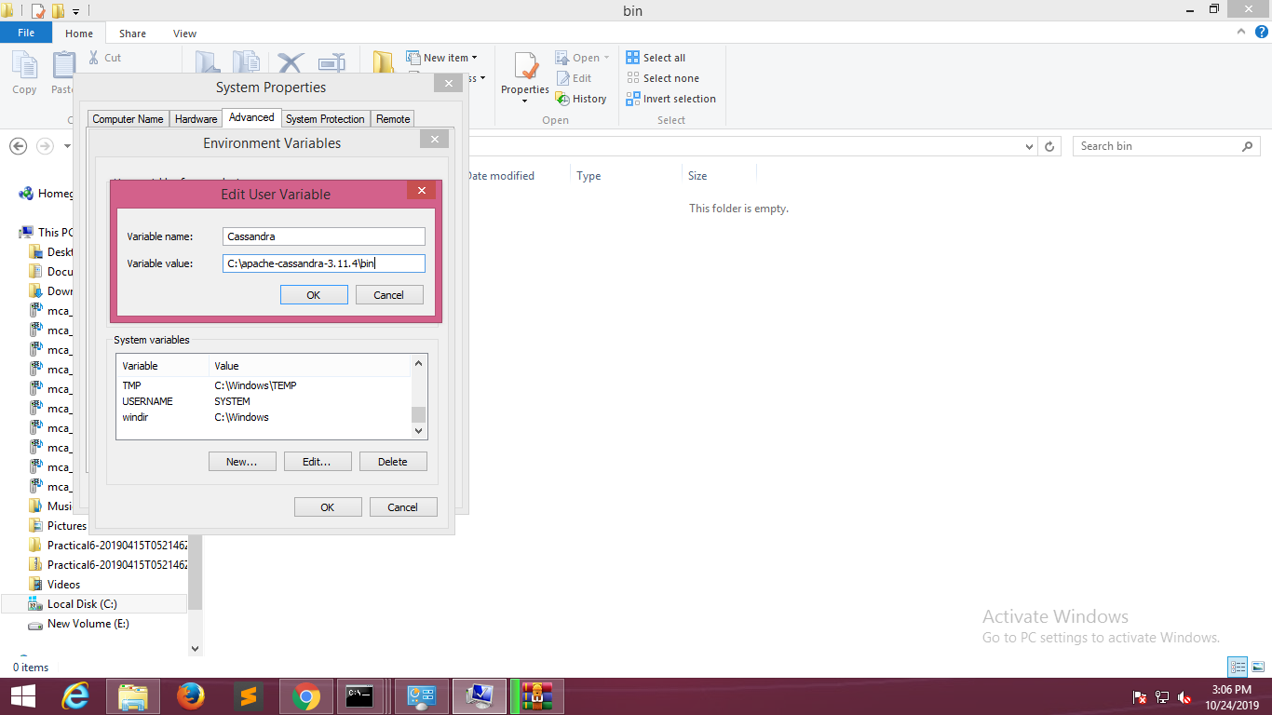

1. Open cmd and type cassandra and open another cmd and type cqlsh.

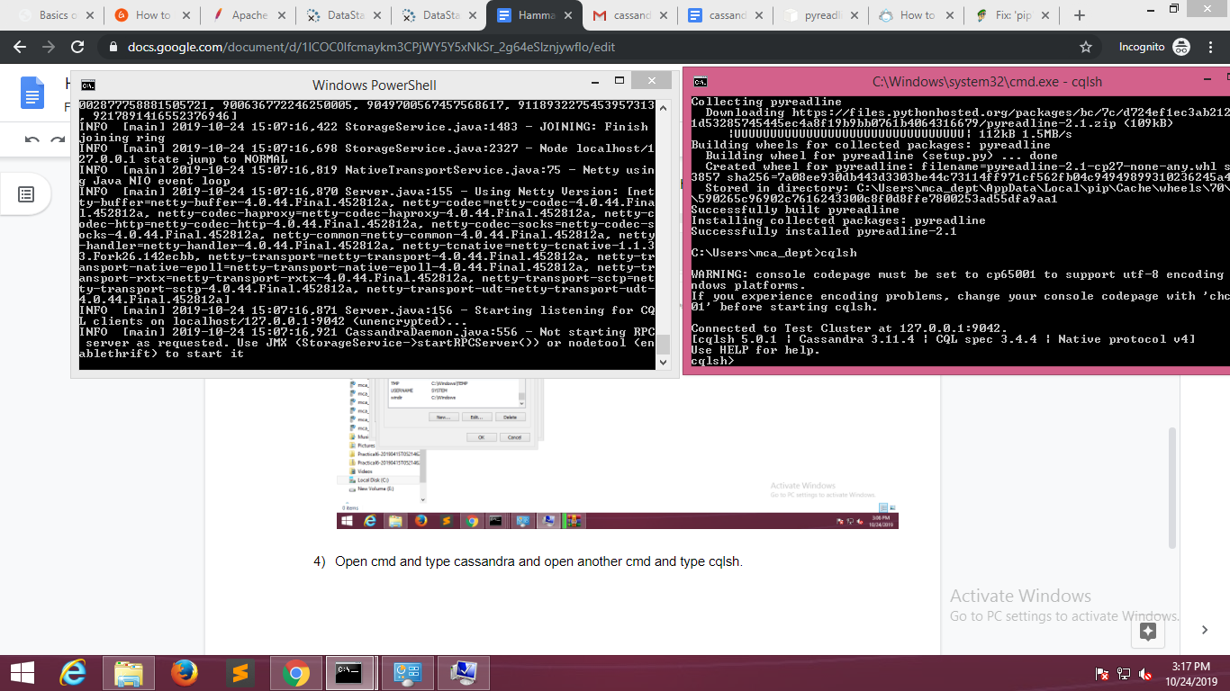

1. Start typing commands like describe cluster, create keyspaces, describe keyspace, etc.

